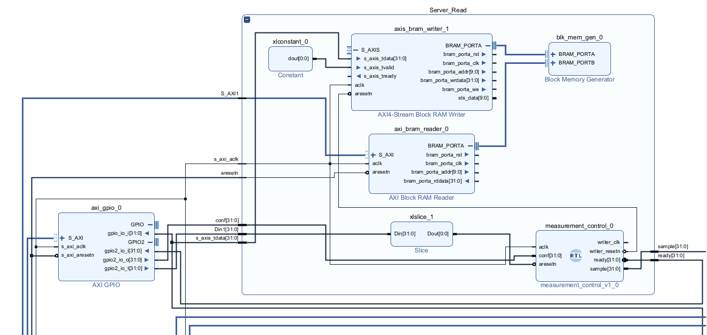

System Clock (125MHz)

Measurementdata 2 Channels  
Channel 1 [15:0]  
Channel 2 [16:31]

# Axi_gpio_0

Setup:  
 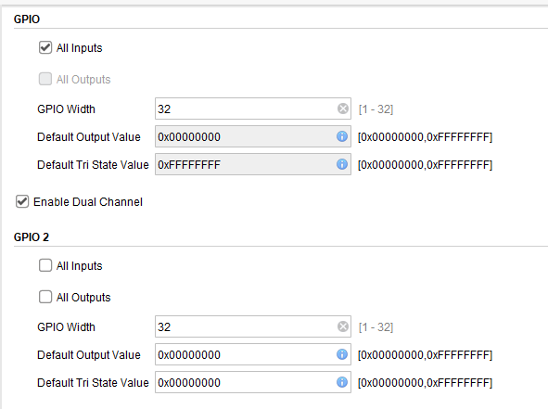

* Axi routing via autoconnect
* Gpio_io_i 🡪 measurement data
* Gpio2_io_i 🡪 ready of measurement_control
* Gpio2_io_o 🡪 ready of measurement_control
* Gpio2_io_t 🡪slice bit31 and connect to aresetn of measurement_control

# Axis_bram_writer_1

Setup:

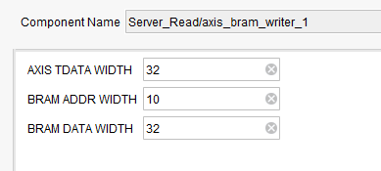

# Axi_bram_reader_0

Setup:  
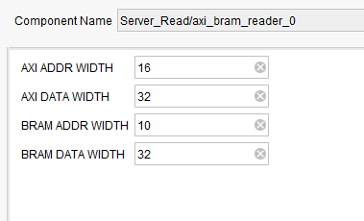

# Blk_mem_gen_0

Setup:  
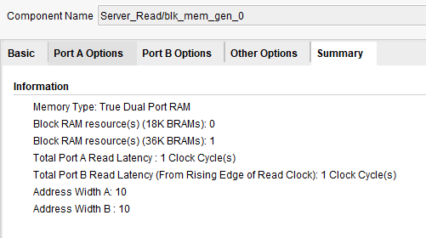

# Measurement_control_0

Setup:  
